Curriculam Vitae
For use in registration process of PSIC
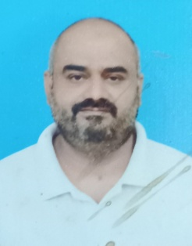
Dr. Imran Ali,
Senior Registrar
Department of Cardiology,
Sheikh Zayed Medical College/Hospital,
Rahim Yar Khan

PERSONAL INFORMATION:
Father’s Name: Muhammad Ali
CNIC No.: 32403-9730613-9
Contact No.: 0333-6442172, 0334-6442172
Email : imranali.dr1@gmail.com
Domicile: Rajanpur, Punjab
Date of Birth: 09/08/1983
Marital Status: Married

Profile:
To built a challenging career and polishing the abilities

QUALIFICATION:
Certificate: Year Baord
FCPS (Cardiolog) 2020 CPSP
MBBS 2009 UHS, Lahore
FSC 2003 Kohat Board
Matric 2000 DG Khan Board

EXPERIENCE:
Total 14 years experience furnished hereunder:
- Presently working as Senior Registrar, Cardiology, SZMC/SZH RY Khan from 18 November 2021.
- Here my work includes doing diagnostic and therapeutic intervention in cath lab and I am doing more 75 pci,s /year since my post graduation in 2020 0ct0ber session
- Medical Officer in Cardiology at SZMC/SZH, RY Khan from November 2019 to November 2021 (Two year).
- Emergency Medical Officer DHQ Hospital, Rajanpur from June 2017 to feb 2019 (1.5 years).
- FCPS Residency in Cardiology of 03 years from January 2013 to April 2016 (CPEIC Multan).
- FCPS Training in General medicine of 02 year from January 2011 to January 2013 Lahore General Hospital, Lahore.
- House Job Medicine & Allied 04 Months January 2010 to April 2010 Lahore General Hospital.
- House Job in General Surgery 05 Months and 17 days from July 2009 to December 2009 Lahore General Hospital.
- House Job in Pulmonology at SZMC/SZH, RY Khan from April 2009 to July 2009 (04 Month).

LANGUAGES:
- Urdu.
- English.
- Punjabi.
- Saraiki.

SKILLS:
- Communication Skills, Medical Tools Awareness.
- Research Article related to my subject.
- Attended multiple station and out of station workshops/conferences.
- Multi-language expertise

REFERENCES:
- Will be provided when required.

___________
Dr. Imran Ali
Fcps cardiology

