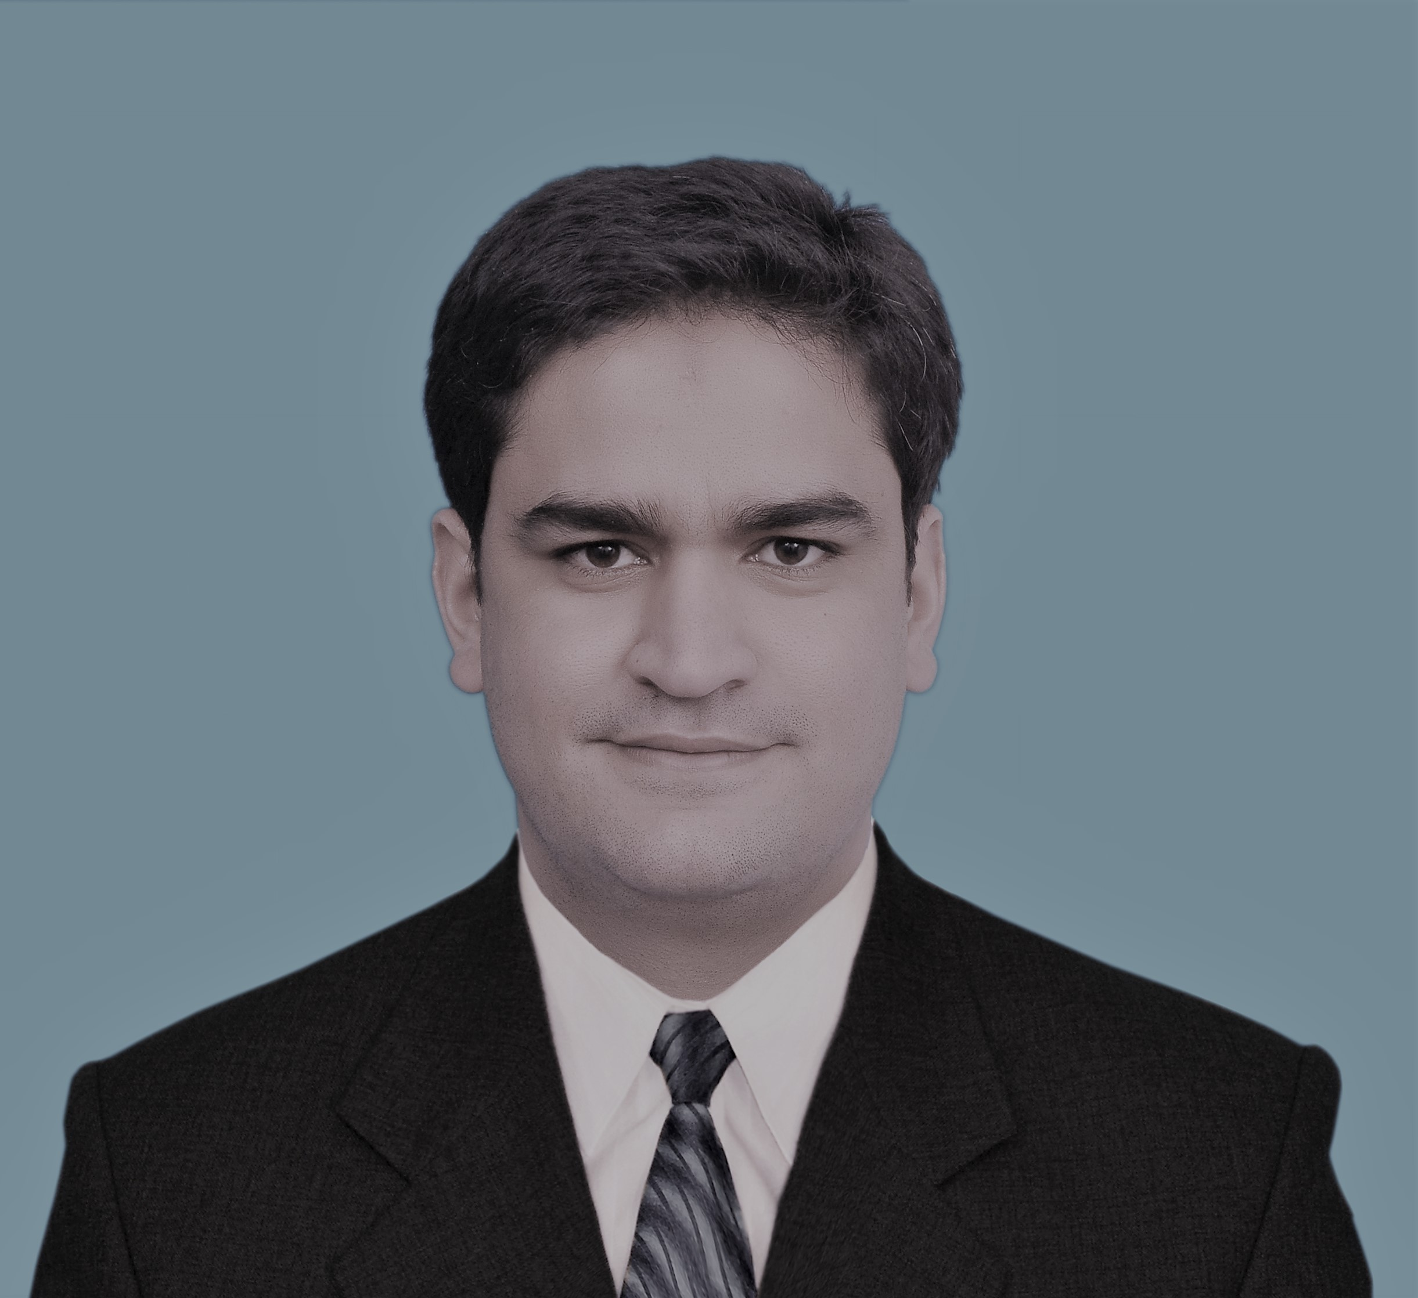
Curriculum Vitae
Dr. Syed Imran Ahmed Kazmi
House No. 102/22-A, street # 8,
Rah e Sakoon Habibullah Colony abbottabad
Tehsil & District Abbottabad
Contact # : 03349040772
03114837282
E-mail: imranahmedkazmi@gmail.com

AIMS AND OBJECTIVE:
- I like to work in healthy environment with aim to help the ailing humanity, to serve the medical profession, to improve the services towards patient and to provide quality services to patients.

PERSONAL INFORMATION:

- Father’s Name : Syed Ahmed Shah
- Date of Birth : 25/02/1987
- N.I.C No. : 13101-1653221-1
- Domicile : Abbottabad (KPK)
- Marital Status : Married
- Languages : English, Urdu, Pashto and Hindko

ACADEMIC QUALIFICATION:

Qualification | Board / University | Year
FCPS Cardiology | CPSP | 2019
MBBS  (Graduation) | KMU Peshawar | 2012
F.Sc  (Pre Medical ) | B.I.S.E Abbottabad | 2005
Matric | B.I.S.E Abbottabad | 2003

PROFESSIONAL Education:
MBBS: 2012 from Khyber Medical University Peshawar
FCPS cardiology: 2019 From CPSP Karachi

PROFESSIONAL Experience:
1.Working as District Cardiologist in BBSTH (DHQ Abbottabad) since April 2020 till date
2. Assistant Prof Cardiology Women Medical College Abbottabad
since Aug 2022 till date.
3. Visiting cardiologist Medikay Cardiac center Islamabad

Special Interest:
- Complex PCI, Bifurcation Lesions, CTO, recent advancements in Intervention cardiology
References;
- Maj Gen(R) Dr. Azhar Mahmood Kayani chief Cardiologist Medikay cardiac centre Islamabad
- Dr. Mujtaba Ahmed Kayani Consultant cardiologist Rawalpindi Institute of cardiology

