Dr. Abdul Wahab Shahid
(awahabas88@hotmail.com)
PMDC No:55843-P
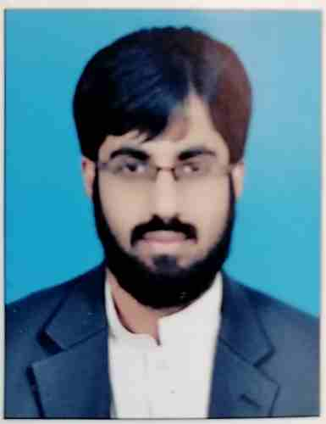

Personal Information:
Name: Dr. Abdul Wahab Shahid
Age: 35 Years
Address: House # 44, Street # 20, G-13/3, Islamabad
Marital Status: Married
Date of Birth: 5th March, 1986
Email: awahabas88@hotmail.com
Cell Number: 0333-5043648
SKYPE ID: live:awahabas88
Height: 5'7"
Weight :64 KG

Career Objective:
To continue my career as a Cardiologist at a topnotch facility considered as one of the world’s leading cardiology hospitals and to devote my skills in the treatment of patients with cardiovascular disorders.
Education:
Year | Qualification | Institution | Grade
2004-9 | M.B.B.S | International Islamic Medical College, Riphah University | A
2003 | HSSC | International School & College of Pakistan, Khaitan, Kuwait | A
2001 | SSC | Gulf Pakistan English School & College, Fahaheel, Kuwait | A

Training & Experience:
2009 House Job Medicine (6 Months)Holy Family Hospital , Rawalpindi
- wards : (3 months )
- OPD : (1 months )
- ER : (1 month )
- CCU : (15 days)
- ICU : (15 days)

2010 House Job Anesthesia (6 Months) Pakistan Institute of Medical Sciences PIMS, Islamabad
- General Surgery OT (2 months)
- Surgical ICU (2 months)
- ENT (1 month)
- MCH (1 month)

2011 Medical Officer (6 months),Bahria town Phase VIII Hospital, Rawalpindi
- Medicine
- Surgery
- Pediatrics
- Emergency
2012- 2014 Training of Internal medicine ( 2 years), MU II Holy Family Hospital, Rawalpindi
    - Male medical ward (6 months)
    - Female medical ward (6 months)
    - Emergency (6 months)
    - CCU (2 months)
    - Gastroenterology (2 months)
    - Nephrology (2 months)
2015-2018 Training of Cardiology(3 years) ,Rawalpindi Institute of Cardiology ,Rawalpindi
- Emergency (4 months)
- Inpatient (3 months)
- OPD (2 months)
- CCU (4 months)
- ETT (2 months)
- ECHO LAB (4 months)
- CATH LAB (6 months)
- Nuclear Cardiology (2 months)
- Cardic surgery (2 months)
- CT Angiography (1 month)
- Electro physiology (2 months)
- Peadiatric cardiology (4 months)

2018 till date Medical officer Rawalpindi institute of Cardiology , Rawalpindi
- CCU ( 6 months )
- ECHO ( 6 months )
- Cardiology ward ( 6 months )
- ER ( 4 months )

2019-2022 Post Fellowship Experience, (3 years) Rawalpindi institute of Cardiology, Rawalpindi
Additional Qualification :
2019 FCPS CARDIOLOGY
2016 MRCP (UK) PART 1
Procedures & Skills:
- Echocardiography
- TOE
- Temporary Pacemaker
- Permanent Pacemaker
- Pericardiocentesis
- Coronary Angiography (800+)
  - Radial Access
  - Femoral access
  - Carotid Angiography
  - Graft study
- Percutaneous Coronary Intervention
- IV Cannula
- IV, IM Injections
- Foley’s Catheterization
- NG Tube
- Ascitic Tap
- Pleural Tap
- ETT
- Liver Biopsy
- SB Tube
- Lumber Puncture
- Arterial Tap
- CVP Line
- Spinal Anesthesia

Synopsis & Dissertation:
Comparison of Angiographic findings in STEMI and NSTEMI patients
Article :
Impact of Angiotensin receptor neprilysin inhibitor on anxiety and depression in patients with heart failure
Presentations:
- Complications of MI
- Peripartum cardiomyopathy
- Guidelines for MVR
- CT angiography
- Diabetic Neuropathy
- Approach to patient with septic shock
- Acinatobector Infection
- Long case on Multiple Myloma
- Long case on Autoimmune Hepatitis
- PPI and risk of Pneumonia
- Fried food consumption and BMI

Workshops:
- Basic Life Support
- Advanced Cardiac Life Support
- Essential Surgical skills with emphasis on Emergency maternal &Child Health Program.
- Communication skills
- IT skills
- Research and Methodology
- Dengue workshop

Conference:

2018 Pakistan Live Interventional Cardiology Conference ,Islamabad
2014 International Gastroenterology Scientific Conference ,Rawalpindi
2010 Tele Conference with French Delegation about ICU management , Islamabad
2022 Pakistan Live Interventional Cardiology Conference ,Islamabad

References:
Provided when required.

