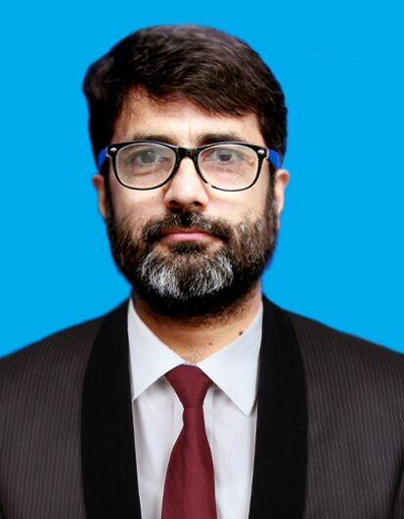

CURRICULUM VITAE

DR. MUHAMMAD MASOOD IQBAL BHUTTA

MBBS
IMM (MEDICINE)
FCPS CARDIOLOGY

MUHAMMAD MASOOD IQBAL BHUTTA

PERSONAL DETAILS:

Date of Birth 26th June 1978
E-mail drmasoodiqbalb@gmail.com
Cell Phone Number 00966 541625809
Address 721 West Compound, KFSH & RC Housing, Takhassusi Road,
Riyadh
Nationality Pakistani

PROFESSIONAL QUALIFICATIONS:

FCPS (Cardiology):

Fellowship degree in Cardiology in 2016 (Five Years Training Programme) from College of Physicians and Surgeons Pakistan after completion of three years training programme in Cardiology from PIC, Lahore and CPEIC, Multan and two years training programme in Nishtar hospital Multan, recognized by Pakistan Medical and Dental Council.

IMM (Medicine):

Two years training programme in Internal Medicine from College and Physicians and Surgeons Pakistan

FCPS-I:

Entrance exam for training in Internal Medicine from College of Physicians and Surgeons Pakistan in 2004

MBBS:

Bachelor degree, graduated from Bahauddin Zakriya University, Multan, Pakistan in October 2002, recognized by Pakistan Medical and Dental Council after completing five years of study programme from Nishtar Medical College, Multan.

PROFESSIONAL REGISTRATIONS:

SCFHS-KSA Senior Registrar-Cardiovascular Medicine 19150825
PMDC-Pakistan Full registration Reg. # 40661-P
CPSP-Pakistan (Medicine)
CPSP-Pakistan (Cardiology) CRD-16-17849

WORK EXPERIENCE:

Currently working as Assistant Consultant Cardiology at King Faisal Specialist Hospital & Research Centre, Riyadhl
With work Experience as:

Details are given below:

S. No | Employer Name & Address | Dates | Job Title
1 | King Faisal Specialist Hospital & Research Centre, Riyadh, KSA | 16/11/2019 to date | Assistant Consultant Cardiology
2 | Ch. Pervaiz Elahi Institute of Cardiology, Multan, Pakistan | 30/05/2015 to 15/11/2019 | Senior Medical Officer Cardiology
3 | Ch. Pervaiz Elahi Institute of Cardiology, Multan, Pakistan | 28/07/2007 to 29/05/2015 | Medical Officer & Postgraduate Training Registrar Cardiology
4 | Punjab Institute of Cardilogy, Lahore, Pakistan | 26/04/2006 to 31/08/2007 | Postgraduate Training Registrar Cardiology
5 | Nishtar Hospital, Multan, Pakistan | 26/04/2004 to 25/04/2006 | Postgraduate Training Registrar Internal Medicine
 | GAP PERIOD | 01/08/2003 to 25/04/2004
6 | Nishtar Hospital, Multan, Pakistan | 01/08/2002 to 31/07/2003 | House Officer Cardiology & Medicine

Gap Period
After Completion of House Job on 31-07-2003, I prepared for the FCPS-I Exam, passed it and waited for the induction in Specialization training till 25-04-2004

PROFESSIONAL SKILLS:

Interventional Cardiology:

Fully trained and experienced to perform independently

- Trans-radial & Trans-femoral Angioplasty
- Trans-radial and Trans-femoral Angiography
- Primary Angioplasty
- Permanent Pacemaker Implantation (PPM)
- Balloon Mitral Valvotomy
- Cardiac Catheterization in Congenital Heart Disease

Emergency Cardiac Procedures:

- Skillful to perform emergency cardiac procedures like Pericardiocentesis, Temporary Pacemaker insertion, CVP line Insertion, Electrical Cardioversion

Echocardiography:

- Skillful to perform Transthoracic echocardiography and Transesophageal Echocardiography

Other Cardiac Procedures:

- Skillful in interpretation of Cardiac Cath data, Exercise tolerance test (ETT)

CLINICAL EXPERIENCE AND RESPONSIBILITIES:

- Day to day care of in-patients by assessment of patients, interpreting their clinical history, performing clinical examination, interpretation of ECG, echocardiography, pathological and radiological investigations.

- Performing daily clinical rounds in CCU and Cardiology ward and decision making in patient management and collaborating with Consultants about management plan.

- Performing on call duties in emergency ward, help in decision making in patient management and performing emergency procedures like; Electrical Cardioversion, TPM insertion, pericardiocentesis and CVP line insertion

- Performing Cardiology Clinics, helping in decision making about management of out-door patients.

- Performing Catheterization lab duties and procedures including performing Coronary Angiography, Coronary Angioplasty and PTMC.

- Teaching residents, house officers and Medical Students on their rotations to Cardiology department, with the Concept of problem based learning.

CLINICAL COURSES:

- Basic Life Support (BLS)
- Advanced Cardiac Life Support (ACLS)
- Procedural Sedation
- Fire & Safety

- Ethics and Human Subject Protection: A Comprehensive Introduction

My Publications:

- Muhammad Ramzan, Hadi Yousuf Saeed, Muhammad Masood Iqbal Bhutta, Farman Ali. Incidence of Contrast-Induced Nephropathy and its Contributing Factors After Cardiac Catheterization in Type II Diabetic Patients. Pak Armed Forces Med J 2018;68(3):639-44

- Babar HAK, Saad AA, Butt ZR, Khan Z, Dastgeer S, Iqbal MM. Severe mitral stenosis; In-hospital outcomes of percutaneous transvenous mitral commissurotomy (PTMC) in patients. Professional Med J 2017;24(6):850-854

- Tariq Mehmood Khan, Ammar Akhtar, Muhammad Ikram Farid, Kashif Ali Hashmi, Muhammad Masud Iqbal Bhutta. Transesophageal Echocardiographic Assessment of Left Atrial Thrombus in Patients of Rheumatic Severe Mitral Stenosis with Negative Result on Transthoracic Echocardiography. Pak Heart J 2021;54(01):315-318

