CURRICULUM VITAE
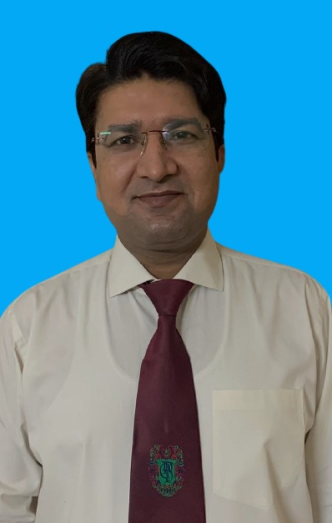
PERSONAL DETAILS

Name: Dr. Azmat Ullah
Father name: Baran Khan
Date of Birth: 01 September 1987
Address: CPSP Regional center near CENAR Hospital Brewery road Quetta
Correspondence Address: Department of Cardiology, Sandeman Provincial Hospital (SPH) Quetta, Balochistan Pakistan.
Telephone: Mobile: 0092 3342423218

Email: dr.azmat@ymail.com
Speciality: Interventional Cardiology

REGISTRATION DETAILS
PM&DC Registration Number: 4721-B
Faculty Registration PMDC: Medical Officer
FCPS fellowship No. CRD-19-24603

QUALIFICATIONS

Certificate/Degree | Institute | Duration
MBBS | Bolan Medical College Quetta, Balochistan Pakistan | 2005-2012
Fellow College of Physicians and Surgeons (FCPS) in Cardiology | College of Physicians and Surgeons Pakistan ( CPSP) | 2014-2019
Fellow College of Physicians and Surgeons (FCPS) in Intervention Cardiology | College of Physicians and Surgeons Pakistan ( CPSP) | Jan 2020 to Jan 2022

PAPERS PUBLISHED
- Impact of concomitant treatment of non-chronic total occlusion lesions at the time of chronic total occlusion intervention (AFPJM 2021)

- Outcome of double kissing (DK) crush versus provisional stenting for left main distal bifurcation lesions (AFPJM 2021)

POSTS HELD
- Classified cardiologist and fellow interventional cardiology at AFIC & NIHD Rawalpindi – Jan 2020 to date (in progress)

- Residency in cardiology at Armed forces institute of cardiology- National Institute of heart diseases Rawalpindi- Feb 2017 to June 2019

- Residency in Cardiology at Bolan medical complex hospital Quetta- July 2016 to Jan 2017

- Residency in Internal Medicine at Bolan Medical complex hospital Quetta- July 2014 to June 2016

- Medical officer at Bolan medical complex hospital Quetta – July 2014 to Jan 2017

- House officer at Bolan Medical complex hospital Quetta- August 2012 to July 2013

CONFERENCES ATTENDED
- ‘Pakistan Live 2019’ held at Pearl Continental Hotel Lahore from 4th -6th April 2019.

- ‘Rhythm for Life 2019’ 16th International conference on Cardiac Electrophysiology at Armed Forces of Institute of Cardiology & National Institute of Heart Diseases ( AFIC & NIHD ) Rawalpindi from 15th to 17th Feb 2019.

- 10th Annual ECG Workshop 2018 –‘ECG in Medical Emergencies’ at Armed Forces of Institute of Cardiology & National Institute of Heart Diseases (AFIC & NIHD) Rawalpindi on 10th November 2018.

- 9th Annual ECG Workshop 2017 –‘ECG in Medical Emergencies’ at Armed Forces of Institute of Cardiology & National Institute of Heart Diseases (AFIC & NIHD) Rawalpindi on 17th November 2017.

- ‘Rhythm for Life 2018’ 15th International conference on Cardiac Electrophysiology at Armed Forces of Institute of Cardiology & National Institute of Heart Diseases ( AFIC & NIHD ) Rawalpindi from 16th to 18th Feb 2018.

- 48th Cardiocon held at Nishtar Medical University & Hospital Multan from 23-25 November 2018.

- 20th Annual Cardiology Update at Pearl Continental Hotel, Bhurban organized by AFIC & NIHD Rawalpindi held on 28-20 June 2019.

- 19th Annual Cardiology Update at Pearl Continental Hotel, Bhurban held from 29th June to 1st July 2018.

WORKSHOPS ATTENDED

- Target Intensive Care Echocardiography Course Course at Armed Forces of Institute of Cardiology & National Institute of Heart Diseases (AFIC & NIHD) Rawalpindi on 15th Sep 2018.

- Cardiac Electrophysiology workshop at 48th Cardiocon held at Nishtar Medical University & Hospital Multan from 23-25 November 2018.

- Communication Skills held from 30th to 1st November 2015 at CPSP, Regional Centre Quetta.

- Research Methodology, Biostatistics & Dissertation Writing at CPSP regional center Quetta 14-17 September 2015.

- Introduction to computer & internet at CPSP regional centre Quetta, 01-03 June 2015.
- Basic Life Support held on 12th February 2016 at CPSP, Regional Centre Karachi.

REFEREES

1. Major General Professor Dr Naseer Ahmad Samore
MBBS, FCPS (Medicine), FCPS (Cardiology), FRCP (Glasgow)
Professor of cardiology/ Medicine AMC
Consultant Interventional Cardiologist & Physician
Armed Forces Institute of Cardiology/National Institute of Heart Diseases, Rawalpindi, Pakistan.
naseersamore@gmail.com
+92 51 9271013
+92 321 5009952

2. Colonel Dr. Mohsin Saif
MBBS, FCPS (MED), FCPS (CARDIOLOGY), MRCP (UK), FRCP (UK)
Fellowship in Interventional cardiology (UK)
Consultant cardiologist and medical specialist
Armed Forces Institute of Cardiology/National Institute of Heart Diseases, Rawalpindi, Pakistan.
mohsinsaif@gmail.com
+92 51 927 2922
+92 321 5845251

