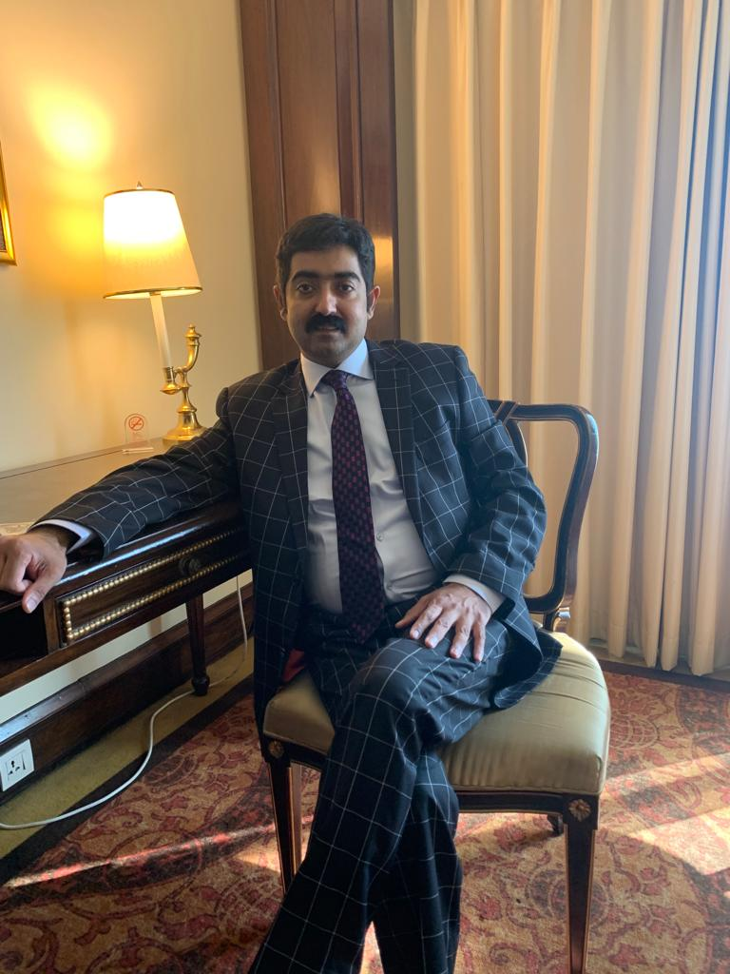

Dr. HAFIZ MUHAMMAD FAIQ ILYAS
MBBS, FCPS (Cardiology)

PMDC Registration No: 52855-P
Postal Address: HOUSE#12A FAISAL GARDEN PHASE#2 SHIKHUPURA ROAD FAISALABAD
Phone: +923338969032 ｜ E-Mail: drfaiqfic23@gmail.com

Academic Qualification:
MBBS, March 2008
PUNJAB MEDICAL COLLEGE FAISALABAD
University of health sciences, Lahore, Pakistan.

FCPS (Cardiology). JUL 2016
Fellow of College of Physicians & Surgeons (Cardiology).
College of Physicians & Surgeons Karachi, Pakistan.
Fellowship No: CRD-16-17870
Professional Experiences

Senior Registrar Cardiology
Faisalabad Institute of Cardiology, Faisalabad 1st September 2021 to Date

Senior Registrar Cardiology
CCU Allied Hospital, FMU Faisalabad September 2020 to September 2021

Senior Registrar Cardiology.
Wazirabad Institute of Cardiology (WIC), Wazirabad. APRIL-2018 – September 2020

Senior Registrar Cardiology.
Faisalabad Institute of Cardiology (FIC), Faisalabad. 28-7-2016 to 25-04-2018.
PUBLICATIONS:
6 in number, published in “THE PROFESSIONAL MEDICAL JOURNAL”
WORKSHOPS & CONFERENCES:
“GULF PCR” IN DEC, 2017 IN UAE
“CAROTID INTERVENTION HAND ON WORKSHOP” IN RIC, RAWALPINDI IN 2018
“ROTABLATOR HAND ON WORKSHOP” IN FIC FAISALABAD 2018
ALL SUPERVISORY WORKSHOPS OF CPSP & UHS

