Dr Sharwan Bhuro Mal
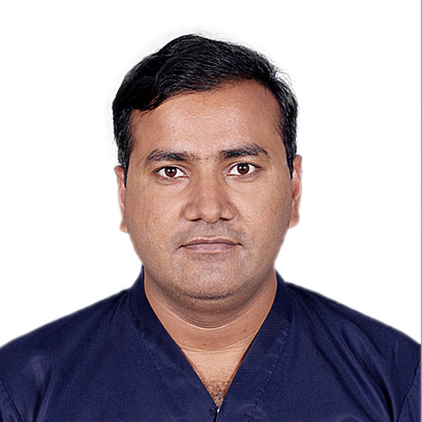
MBBS, FCPS (CARDIOLOGY)

Interventional cardiology fellowship Tabba heart institute Karachi.

Assistant Professor &Interventional Cardiologist, Isra University Hospital,
Hyderabad

Visiting faculty at Tabba heart institute Karachi

Patel hospital Karachi and NMC Karachi.

Date of birth 08/04/1983
CNIC 4430194564409
PMDC #: 53638-S
Domicile: Tharparker, Sindh ​
Phone No.: 0345 2764852, 022-6115621
E-Mail: sarwanbk_15@yahoo.com
Flate # 504 Salama terrace opposite police headquarter garden west Karachi.

Objective:
To continue my career as a Cardiologist at a topnotch facility considered as one of the country’s leading cardiology hospitals and to devote my skills in the treatment of patients with cardiovascular disorders.
My Basic Strengths:
I have worked in critical areas, wards and OPD; I can manage all cardiac emergencies. I performed huge number of pericardiocentesis, TPM, right heart catheterization, left heart catheterization and coronary and graft angiography procedure under kind supervision of my mentors as well as independentat Tabba heart Institute during my adult cardiology fellowship. I worked as consultant at Tabba heart Institute after fellowship.Iam doing my interventional training at Tabba heart Institute, which includes coronary, peripheral and valvular intervention.

Interventional fellow since Jan 2018 and to be continued till December 2019
Worked as consultant cardiologist since July 2016 to December 2017
ACLS AND BLS INSTRUCTOR at Tabba Heart Institute
Research Clinical research certification course from CTU DUHS Karachi

Academic profile
EXAMINATON | YEAR | INSTITUTE | BOARD | DIVISION/GRADE
FCPS II adult cardiology | July 2016 | TABBA HEART INSTITUTE KARACHI | COLLEGE OF PHYSICIANS AND SURGEONS PAKISTAN | 1ST ATTEMPT
Intermediate module | March, 2012 | AGHA KHAN UNIVESITY HOSPITAL KARACHI1 | COLLEGE OF PHYSICIANS AND SURGEONS PAKISTAN
FCPS PART -1 | Oct, 2009 |  |  | 1ST ATTEMPT
MBBS | 2007 | LUM&HS JAMSHORO | LUM&HS JAMSHORO | 1ST DIVISION
Intermediate | 2001 | GOVT DEGREE BOYS COLLEGE QASIM ABAD HYDERABAD | Board of intermediate and secondary education Hyderabad | Grade A
Matriculation | 1999 | GOVT BOYS HIGH SCHOOL CHACHRO | Board of intermediate and secondary education Hyderabad | Grade A

Previous Work experience:
6 months house job in internal medicine from LNHKarachi (Jan 2008 to July 2008).
6 months house job in general Surgery from Liaquat University of medical and health sciences Jamshoro (august 2008 to Feb. 2009).
6 months trainee RMO in pediatrics ward at Liaquat university hospital Hyderabad (March 2009 to august 2009).
Internal medicine residency fromLiaquat national hospital Karachi from 20 Feb. 2010 to 31stDecember 2010.
Internal medicine residency fromAgha khan university hospital Karachi from 1stJan 2011 toJune 2012.

Subspecialty rotations and experience:
Position Held | Specialty | Period | Institute
Resident | Pulmonology | 2 Months | LNH Karachi
Resident | Internal Medicine | 1 year and 1 Month | LNH Karachi
Resident | Endocrinology | 2 Months | LNH Karachi
Resident | Internal medicine | 11 months | AKUH Karachi
Resident | Cardiology | 2 Months | AKUH Karachi
Resident | ICU & Critical Care | 2 Months | AKUH Karachi
Resident | Gastroenterology | 3 Months | AKUH Karachi
Resident | Nephrology | 1 Month | AKUH Karachi
Adult cardiology fellow at NICVD since July 2012 to June 2013 worked in general ward CCU, ETT/ECHO and catch lab.
FCPS FELLOW in adult cardiology @ Tabba heart institute since July 2012 to June 2016
Position Held | Rotation | Period
Fellow cardiology | Ward/ER/Clinics | 6 Months
Fellow cardiology | Echo | 9 Months
Fellow cardiology | ETT/MPI | 4 Months
Fellow cardiology | Cath Lab | 4 Months
Fellow cardiology | Cardiothoracic surgery | 6 Months
Fellow cardiology | Pediatric Cardiology | 6 Months
Fellow cardiology | Electrophysiology | 1 Month
Workshops:
Strategies and Skills in communication with patients from Liaquat national hospital Karachi.
Work shop on ECG interpretation organized by Pakistan heart and rhythm society.
Workshops from CPSP Karachi, on communications skills, IT and computer, Research and methodology.

Seminars and courses & CMES:
Certificate of participation in Research Ethics Workshop held at Patel Hospital Karachi on 18th November, 2016 in collaboration with CBEC SIUT.
Certificate of participation in Pakistan Society for Rheumatology Meeting held @ Patel Hospital Karachi on Friday 28thOct 2016.
Certificate of participation ANTICOAGULATION IN ATRIAL FIBRILLATION & MANAGEMENT OF DVTheld at Ziauddin Hospital Karachi on May 7th 2016.
Certificate of participation in Echo Conference at Tabba Heart Institute accredited by DUHS Karachi on Jan 9 2016.
Certificate of participation in CME Symposium RADIATION AND MEDICAL IMAGING: HAZARDS TO HEALTH CARE WORKERS, on May 16 2015.
Certificate of participation in CME workshop Dyslipidemia Update held on February 28, 2015 at Tabba heart institute.
Certificate of participation in Cardiology review course – 2014.
Certificate of participation An Approach for Critical Review of Biomedical Literature at 19th
Postgraduate Medical Education Conference on Enhancing Academic Standards for Quality Care on Saturday, May 31, 2014.
Certificate of achievement by PAKISTAN INSTITUTE OF MANAGEMENTKarachi for Diploma in Spoken English Program. Nov 7 2012.
Certificate of participation in Cardiovascular Expert Symposium by Dr. David D. Waters held on September 8th, 2012 in Karachi Pakistan.
Coronary Artery Disease Review Course by Pakistan Heart Association held on 15th December 2012.
Basics of Multi-Modality Cardiac Imaging at Tabba Heart Institute December 8th&9th 2012.
Certificate of Participation in 17th Annual Postgraduate Medical Education Conference on Moving towards Competency –based Academic Practice held on May 25, 2012.
Certificate of Participation in CME session TOBACCO CONTROL: CURRENT CHALLENGES FOR PAKISTAN at AKUH Karachi on Wednesday, November 16, 2011.
Certificate of Participation in the 1st Annual Comprehensive ECG Course held at PC Hotel Karachi by Pakistan Heart Rhythm Society on Saturday, 30th July, 2011.
Certificate of Participation in Seminar on Safety in Postgraduate Medical Education: Challenges in Training and Patient Care held at AKUH may 20-21, 2011.
Certificate of Participation in Time Management Programheld at AKUH on March 24, 2011.
Certificate of Participation in a Seminar on TB on world TB day held at AKUH Karachi on Tuesday, March 22, 2011.
Certificate of Participation in National CME Series 2010, at DUHS Karachi held from February 2010 to December 2010. (30 CME credit hours)
Certificate of Participation in CME on osteoporosis THE SILENT THEIF held on 13thnov 2010.
Certificate of Participation in CME on Diabetes at LNH Karachi on Thursday 11th November 2010.
Certificate of Participation in CME on obesity held at LNH Karachi on Tuesday 28th September 2010.
Certificate of Participation in Workshop on Issues & Strategies in Communicating with Patients held on Monday 19th July, 2010.

