 | CURRICULUM VITAE
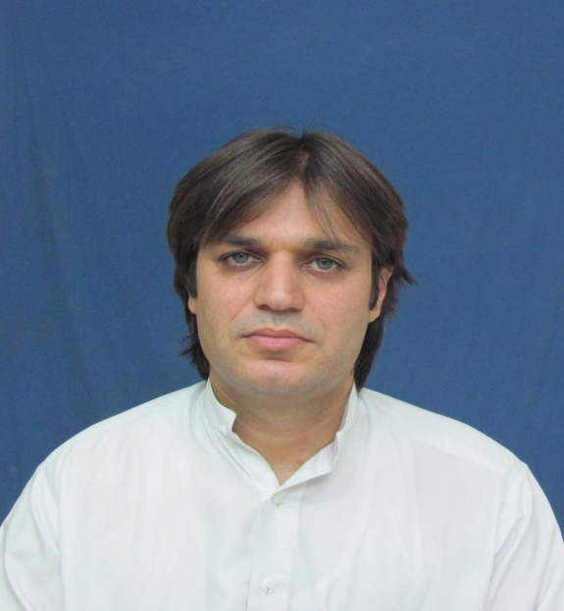 | Dr. ASFANDIYAR  Mobile # 00923335038876  E-mail: asfandyar861@live.com  FCPS (Cardiology) June 2014  PAKISTAN

POSITION APPLIED FOR

PSIC full membership

EDUCATIONAL BACKGROUND
2014 FCPS CARDIOLOGY
2010 IMM( Medicine and Allied)
2000-2005 MBBS

PROFESSIONAL CLINICAL EXPERIENCE
INTERVENTIONAL CARDIOLOGY:
Worked under the supervision of Professor Dr Mahmoodul Hasan for 5years in Cath lab Hayatabad Medical Complex and later on at Kuwait teaching hospital Peshawar with Dr Muhammad Abdur Rauf for one year. During this duration i performed numerous interventional procedures including mananagement of any complications initially under supervision and later independantly.
Currently for last one and half month i am running a separate cath lab(a first at Mardan) with a group of other cardiologists. Till now we have performed 11 coronary interventions.

CONSULTANT CARDIOLOGIST(AP) : Presently working as Consultant Cardiologist (Health Department KPK) posted at MTI MMC & TH Mardan

SPECIALIST CARDIOLOGIST
I have worked as specialist cardiologist at WAPDA Hospital Tarbela from 20th February 2014 till January 2015. During my this work experience I was running independently the non invasive adult cardiology department including performing and interpreting ECG, ETT, ECHO, Holter both for BP and rhythm.
5 YEARS RESIDENCY IN CARDIOLOGY UNIT PGMI HMC HAYATABAD.
I have completed 5 years residency in cardiology unit HMC, PGMI, Hayatabad under the supervision of Dr Mahmood Ul Hassan. I was given hand on clinical experience regarding daily case presentation, active management of admitted patient, running out patient Department, managing cardiology emergencies, doing procedures like CPR, TPM, Pericardiocentesis, central lines passing, Preparing patient for angiography and PCI, bedside echocardiography. Along with this I was also used for teaching history taking and physical examination to final year medical students.
Experience as resident in medical unit
(12th September 2006 to 30th November 2009)
I have worked as resident general practitioner under supervision of Prof Dr Muhammad Noor Wazir in medical unit of PGMI HMC KPK Peshawar Pakistan. I was practicing general medicine along with exposure to surgery Gyne/Obs, Paeds, Ophthalmology.
Experience as Senior Medical Officer Cardiology Rehman Medical Institute
I have worked as a Senior Medical Officer in Cardiology Department mostly CCU. I was responsible for management of Cardiac emergencies, Post Interventions patients management and performing Central lines, TPM, Pericardiocentesis.
professionally skilled and competent in
1 passing cvp lines
2 passing tpm
3 pericardiocentesis
4 coronary angiography, Peripheral Angiography, PCi, Pacemakers AND PTMC
6 passing ett and cpr
7 dc cardioversion(BLS and ALS)
8 invasive &non invasive mechanical ventilator management
9 BLS AND ACLS AHA CERTIFIED

PERSONAL ATTRIBUTES:
I describe myself as a calm, confident, flexible, resilient and hardworking doctor, I am confident of my interpersonal and communicational skills. I am clear and logical in my thinking, know my limitations and never hesitate in seeking expert help when needed. I am considerate to all my colleagues. I enjoy working as part of a team. I am always enthusiastic to learn new things and am highly committed to my personal and professional development.
Workshop and seminars Attended
- BLS certified from American Heart Association(AHA)
- ACLS certified from AHA
- Cardiopulmonary resuscitation workshop at PGMI LRH KPK Peshawar
- Electrocardiography (ECG) workshop at PGMI LRH KPK Peshawar
- Research methodology work shop at CPSP regional center KPK Peshawar
- Communication skills work shop at CPSP regional center KPK Peshawar
- Computer workshop test at CPSP regional center KPK Peshawar
- Cardiology seminar (MINERVA) at PC hotel LAHORE PUNJAB
- Cardiology seminar at PGMI LRH KPK Peshawar
- Cardiocons and Pakistan live

RESEARCH WORK
- Frequency and complications of Ischemic Mitral regurgitation in patients with Acute coronay syndrome. JPMI
Causes of Atrial Fibrillation in a series of 164 patients-local experience at DHQ level. PJMHS, Apr-Jun2020; 14(2):264-65
- Thrombolytic therapy use in peripheries of KPK. PJMHS, Apr-Jun2020; 14(2):269-70
- Frequency of Coronary artery anomalies in adult patients undergoing coronary Angiography for ischemic heart disese. Med Forum July 2020;31(7):33-36
- Prevalence of Depression and anxiety in patients presenting with Acute Coronary syndrome to Mardan Medical Complex. Pak Heart J. 2020;53(04):359-64
- Comparison of vagal maneuvers vs verapamil for cardioversion of AVNRT. A comparative cross sectional study. JAMC (MANUSCRIPT ACCEPTED BUT NOT YET PUBLISHED)

References
- Dr Mahmood ul Hassan
Professor Cardiology, PGMI HMC KPK Peshawar
Cell NO. 0300 5906139
mahmoodlrh@yahoo.com

- Dr Mushtaq Ahmad
Professor Cardiology Department MTI MMC Mardan
Cell NO. 03009175470

- Dr Abdul Rauf
AP Cardiology
Kuwait Teaching Hospital Peshawar.
03439440544
dr.raufkhan@yahoo.com

