CURRICULUM VITAE
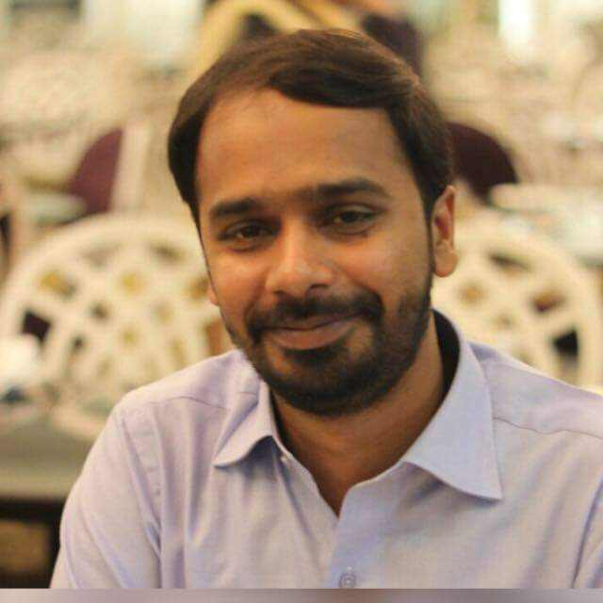

Dr. FAHAR ADNAN
MBBS, FCPS (Cardiology)
Asst professor of cardiology, CPEIC, Multan.

DR.FAHAR ADNAN

OBJECTIVE:

To work in a professional institute and to reach a top level by contributing regularly to its objectives through hard work, dedication, positive attitude, effective use of knowledge and clinical skills to achieve the institutional goals.

PERSONAL DETAILS:

- Date of Birth 16 september 1983
- No of Dependents. 4(parents,wife and daughter)
- E-mail dr.faharadnan@gmail.com
- Cell Ph # 0092 3338203919
- Address flat number 12 doctors hostel, CPEIC, Multan.

PROFESSIONAL QUALIFICATIONS:

- FCPS II(cardiology) College of Physicians and Surgeons, Pakistan. 2015
- INTERNAL MEDICINE TRAINING(IMM)College of Physicians and Surgeons, Pakistan.2012
- FCPS-I(Medicine) College of Physicians and Surgeons, Pakistan. Nov 2010
- MBBS University of health sciences, Lahore, Pakistan. Jan 2008

PROFESSIONAL REGISTRATION:

- PMDC-Pakistan Full registration Reg. # 54434-P
- CPSP- Pakistan (FCPS Cardiology) CRD-15-16291

WORK EXPERIENCE:

Assisstant prof of cardiology, CPEIC Multan. 2018 to Date

Senior Registrar Cardiology, CPEIC Multan. 2016

Post graduate Medical officer, AIMC, Lahore.2010

Total clinical experience in tertiary care hospital = 13 years.

CLINICAL COURSES:

- Basic Life Support (BLS)
- ACLS

RESEARCH:

Research on topics:

- Clinical Significance of lead AvR in prediction of culprit artery in patients with inferior Wall myocardial infarction .
- Association of hyperurecimea with critical coronary artery disease.
- Risk assessment of patients after ST segment elevation myocardial infarction by killip classification: An Institutional Practice
- Severe coronary artery disease and metabolic syndrome in patients with acute coronary syndrome.
- Left main stem disease on coronary angiography in patients with non ST segment elevation myocardial infarction
- Frequency of non ST elevation myocardial infarction on acute coronary syndrome with normal ECG
- Effectiveness of high dose statins among acute coronary syndrome patients presenting at a tertiary care hospital

WORKSHOPS:

- Introduction to Computer and Internet.
- Research Methodology, Biostatistics and Dissertation Writing.
- Communication Skills.
- Education and planning
- Assessment of competency

CLINICAL EXPERIENCE AND RESPONSIBILITES:

- Day to day care of in-patients by assessment of patients, interpreting their clinical history, performing Clinical examination, interpretation of ECG, echocardiography, pathological and radiological investigations.

- Performing daily clinical rounds in CCU and cardiology ward and decision making in patient management and collaborating with consultants about management plan.

- Performing on call duties in emergency ward, helps in decision making in patient management and performing emergency procedures like; Electrical cardioversion TPM insertion, pericardiocenteces, CVP line insertion & echocardiography.

- Performing cardiology opd clinics twice weekly, helping in decision making about management of out-door patients.

- Assisting transthoracic and transesophageal echocardiography list twice a week.

- Performing catheterization lab duties twice weekly, assisting coronary angiography, cardiac catheterization, assisting coronary angioplasty, assisting PTMC and PPM insertion.

- Analysis and reporting of CT Coronary Angiography.

CLINICAL PROCEDURAL SKILLS:

General Procedures Special Procedures

- IV Cannulation - Pericardiocenteces
- Blood Sampling - Transvenvous pacemaker insertion
- Endotracheal Intubation - Coronary Angiography
- Arterial Blood Gas Sampling - Cardiac Catheterization
- Nasogastric Intubation - Exercise tolerance test(ETT)
- Lumbar Puncture - Echocardiography
- Pleural & Ascetic aspiration
- CVP line insertion

CPEIC is tertiary care hospital, which serves 5million population. Its a high volume cardiac centre. During year 2019/20 about 6000 Angiographies, 2500PCI, 250 PTMC, 200PPM, 1500 CABG, 200 peads cardiology cardiothorasic procedure done.

REFEREES:

Prof Dr Ijaz Ahmed Dr. Arsalan Masood
FCPS(medicine) FCPS(cardiology) MCPS(Medicine) FCPS(Cardiology)
Consultant cardiologist Associate Professor of Cardiology
Chief of cardiology Jinnah Hospital,Lahore
CPEIC, Multan Email : arsalanmasood82@gmail.com
Email. ijazas@yahoo.com

Dr. Tariq Abbas
MBBS, MRCP(UK)
Prof. of Cardiology &
Head of Cardiology Department
Bahawal Victoria Hospital
Bahawalpur, Pakistan
Ph. 0092 333 6146264

