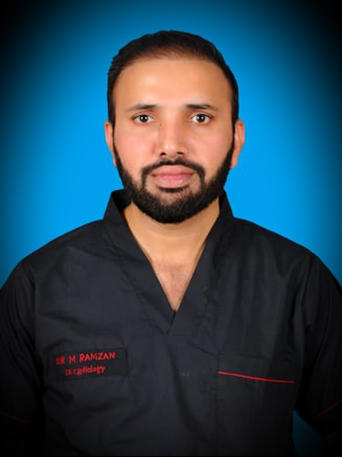

CURRICULUM VITAE

Dr. MUHAMMAD RAMZAN
ASSISTANT PROFESSOR CARDIOLOGY

MBBS,MCPS(MEDICINE)
FCPS (CARDIOLOGY JULY 2013)
FCPS(INTERVENTIONAL CARDIOLOGY 2021 )

My Clinical Interests

- Interventional cardiology
- Cardiac imaging including TTE,TOE.
- Clinical Cardiology

PERSONAL DETAILS:

- Date of Birth 01^{ist} April 1979
- E-mail drmrf786@yahoo.com
- Cell Ph # +92 03216353350
- Address al-Azhr science school, Hameed Abad colony,vehari road Multan
- Nationality Pakistani

PROFESSIONAL QUALIFICATIONS:

MBBS.Punjab,Pakistan
MCPS(MEDICINE)
FCPS (CARDIOLOGY JULY 2013)
FCPS(INTERVENTIONAL CARDIOLOGY 2021 )

PROFESSIONAL REGISTRATION:

- PMDC-Pakistan Full registration Reg. # 47109-P
- CPSP-Pakistan (Medicine) MED-2007-099-3844
- CPSP- Pakistan (Cardiology) CRD-13-13632
CPSP-Pakistan (Interv.cardio) IVC-2019-101-92

WORK EXPERIENCE:

- Currently working as AssistantProfessor of cardiology at Ch. PERVAIZ ELAHI institute of cardiology Multan.
With work experience as:
- Post Fellowship Experience seven Years and nine month.
- Total experience in cardiology twelve years.
- Total experience in medicine and cardiology fifteen years.
- One month locum job at Hamad Heart Hospital, Doha,Qatar as specialist cardiology from 10-02-18 to 10-03-18.

PROFESSIONAL SKILLS:

- Interventional Cardiology:

Fully trained and experienced to perform independently

- Trans-radial & Trans-femoral Angioplasty/ Primary Angioplasty.
- Trans-radial & Trans-femoral Angiography
- Balloon Mitral Valvotomy (BMV)
- Cardiac catheterization in congenital heart diseases

- Emergency Cardiac Procedures

Skillful to perform emergency cardiac procedures like, Pericardiocentesis, Temporary pacemaker insertion, CVP line insertion, Electrical Carioversion.

- Echocardiography

Skillful to perform transthoracic echocardiography and Transesophageal echocardiography.

- Other Cardiac Procedures

Skillful in interpretation of cardiac cath data, treadmill stress test (TMT).

CLINICAL EXPERIENCE AND RESPONSIBILITES:

- Day to day care of in-patients by assessment of patients, interpreting their clinical history, performing Clinical examination, interpretation of ECG, echocardiography, pathological and radiological investigations.

- Performing daily clinical rounds in CCU and cardiology ward and decision making in patient management.

- Performing on call duties in emergency ward, helps in decision making in patient management and performing emergency procedures like; Electrical cardioversion TPM insertion, Pericardiocentesis, CVP line insertion,

- Performing cardiology clinics twice weekly, helping in decision making about management of out-door patients.

- Performing catheterization lab duties twice weekly, performing Coronary angiography, Cardiac catheterization, Coronary angioplasty/primary angioplasty and PTMC.

- Performing TTE and TOE list for around 60 patients per week.

- Teaching our residents, house officers and medical students on their rotations to cardiology, with the Concept of problem based learning.

CLINICAL COURSES:

- Basic Life Support (BLS)
- Advanced cardiac life support(ACLS)

RESEARCH:

Research on topics:
- “Contrast induced nephropathy and its contributing factors after cardiac catheterization in type-2 diabetic patients”

- “Efficacy of Streptokinase in Diabetic versus Non-Diabetic Patients presenting with Acute ST Elevation Myocardial infarction.”

- “Frequency of complete heart block in acute inferior wall myocardial infarction and its relation with severe obstructive disease of the infarct related artery”

- “Frequency of Atrial Fibrillation in post-operative Coronary Bypass Grafting Surgery Patients.”
(Published in Pakistan medical and dental council recognized journals)

WORKSHOPS;
- Introduction to Computer and Internet.
- Research Methodology, Biostatistics and Dissertation Writing.
- Communication Skills.

LANGUAGE SKILLS:
- Fluent in English, Urdu and Punjabi.
- Basic Arabic spoken

REFEREES:

Dr. Ijaz Ahmad  Prof. of Cardiology &  Head of Cardiology Department  CH. Pervaiz Elahi Institute of Cardiology Multan, Pakistan  Ph. 0092 61 9201045/2065  Email: ijazas@yahoo.com | Dr.Muhammad Sohail Saleemi  Assistant Professor of Cardiology  CH. Pervaiz Elahi Institute of Cardiology Multan, Pakistan  Ph.+923336101790  Email: saleemi146@yahoo.com

Dr Badar Ul Ahad Gill
BSc, MBBS, MCPS (Med),
MRCP (UK), MRCP (London)
Assistant Professor of Cardiology
C.P.E.I.C Multan
Email;drbadargill@yahoo.com
Ph.; +923008630727

