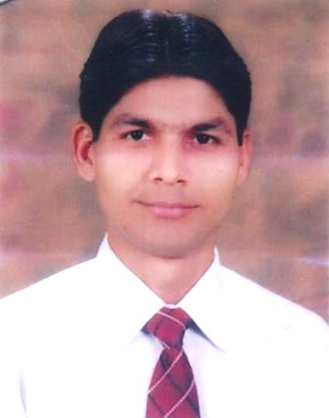
Dr.MAHESH KUMAR
M.B.B.S, FCPS (cardiology), Interventional Cardiologist

Address: Flat# 904,9th Floor, B-Block, Naz Plaza, Opposite Nishat Cinema, M-A Jinnah Road Karachi, Sindh, Pakistan.
E-mail: mahesh_bcmc@yahoo.com, batramahesh903@gmail.com
Contact: 0092-3337332262

PROFESSIONAL OBJECTIVE | With the personal and professional qualification and with career achievements, Seeking a challenging position as a Medical Doctor utilizing my education, knowledge & clinical skills & experience for the better health of the society.
EXPERIENCE  (Present) | National Institute of Cardiovascular Diseases (NICVD) Karachi  - Sep 2017 to date |  |  | Assistant Professor: Currently working as Assistant professor of Cardiology
EXPERIENCE | NICVD Karachi  - Sep 2015 to Aug 2017  PNS Shifa Hospital  - Apr 2015 to Aug 2015  Agha Khan University Hospital  - May 2014 to Apr 2015  NICVD Karachi  - Dec 2013 to Mar 2014  NICVD Karachi  - Nov 2010 to Nov 2013  Jinnah Postgraduate Medical Centre Karachi  - Feb 2009 to Oct 2010  Karachi Adventist Hospital Karachi  - Jul 2008 to Feb 2009  Civil Hospital Karachi  - Apr 2007 to Apr 2008 |  |  | Fellowship: Completed two years fellowship training in interventional cardiology  Registrar: Worked as Registrar in the department of cardiology.  Senior medical officer: Worked as Senior medical officer in the emergency department.  Resident medical officer: Worked as Resident medical officer in the outpatient department of cardiology.  Postgraduate trainee: Worked as postgraduate trainee in the department of cardiology.  Postgraduate trainee: Worked as a postgraduate trainee and rotated through Department of Endocrinology, Nephrology and Neurology for two months in each.  Postgraduate trainee: Worked as postgraduate trainee in the Department of medicine.  Internship training: After a screening process, I was selected for one-year internship training in Surgery and Medicine including Paediatric Medicine and ophthalmology.
ACADEMIC QUALIFICATIONS | Degree | Year | Division obtained |  | Board/University
 | FCPS cardiology | 2015 | Pass |  | College Of Physicians & Surgeons Pakistan
 | M.B.B.S | 2007 | 1st |  | Liaqat University Of Medical And Health Sciences Jamshoro
 | Intermediate | 2000 | 1st |  | Board Of Intermediate And Secondary Education Larkana
 | Matriculation | 1998 | 1st |  | Board Of Intermediate And Secondary Education Larkana
PERSONAL PROFILE | Father’s Name |  |  | CHANDAN MAL
 | Date of Birth |  |  | 02 Jan, 1983
 | CNIC No. |  |  | 43102-2473811-5
 | Passport No. |  |  | CA4228112
 | PM & DC Reg. No. |  |  | 51934-S
 | Nationality |  |  | PAKISTANI
 | Religion |  |  | HINDU
 | Marital Status |  |  | MARRIED
Honours / Awards | - Graduated with distinctions (Honours) in Physiology, Pathology, Medicine and Paediatrics  - Awarded Gold Medal in Final professional annual M.B.B.S examinations.
COMPUTER KNOWLEDGE | MS Office Applications and power point  Knows browsing & internet.
LANGUAGES | English (write, understand & speak)  Urdu (write, understand & speak)  Sindhi (write, understand & speak)  Hindi (write, understand & speak)
Hobbies & Interests | I watch informative programs with interest.  I rejuvenate my mind with meditation, music and long walk.  In my free time, I love to attend parties, family gatherings, use internet and watch movies.  I love to watch and play cricket and chess.
CERTIFICATION/  WORKSHOPS | - Workshop on Computer & Internet (College of Physicians & Surgeons Pakistan) 2010.  - Workshop on Communication Skills (College Of Physicians& Surgeons Pakistan) 2010.  - Workshop on Research and Methodology (College of Physicians & Surgeons Pakistan) 2010.  - BLS (Basic Life Support) certified through American board of heart Association 2015.  - ACLS certified through American board of heart Association 2015.  - International English Language Testing System, IELTS scored band 7.0 overall, Speaking: 7 Listening: 7, Writing: 7, Reading: 7, Overall Score: 7.  - Attended Emergency Cardiovascular Course at Tabba Heart Institute Karachi.  - ECG Course at NICVD Karachi.  - Attended 7th National Symposium of Pakistan endocrine society at Karachi.  - Attended 1st Annual Dr Abdul Haque Khan Memorial International Symposium at Karachi
REFERENCES | Reference will be furnished upon request

