Dr. Muhammad Ahmad Raza Butt
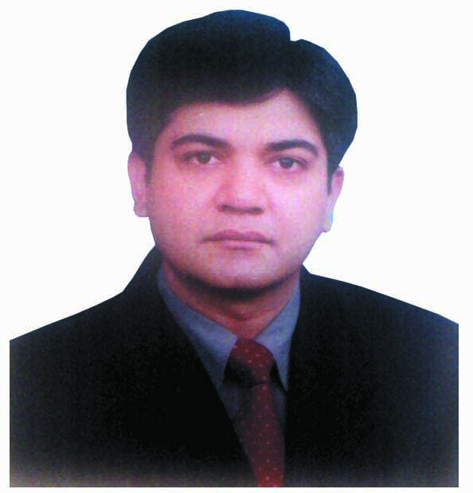

Mbbs(Pb), Dip-Card(UHS),
MD cardiology(UHS),
109-A, Askari-10, Lahore Cantt, Pakistan .
cell: +92-321-4632266.
E:mail:drrazabutt@yahoo.com
 | Personal details
Date of Birth: August 01, 1972 | Nationality: Pakistani (by birth) | Driving Licence: Full
Maital Status: Married | NIC No: 35202-2392912-3 | Religion: Islam

QUALIFICATIONS.
MD Cardiology( UHS)………….2016
* | Passed in 2016 from the University of Health Sciences, Lahore, Pakistan
* | Post Graduate Medical Institute, Bird wood Road, Lahore, Pakistan.
* | Training 6 years at Punjab Institute of Cardiology, Jail Road, Lahore, Pakistan.
* | …..July 03, 2004 ---- Apr, 2010 (5– Years and 10 months).
* | Synopsis approved, thesis completed and deposited.  Topic; Comparison of Multidetector CT Angiography with conventional coronary angiography for detection of post CABG graft patency.
* | Passed the exam in june, 2016.

Diploma in Cardiology,……..2008
* | Passed in 2008 from the University of Health Sciences, Lahore Pakistan.
* | Course attended at Post Graduate Medical Institute, Bird wood Road, Lahore.
* | Main subjects: Clinical Cardiology
* | …..Sep: 15, 2001, - Sep 14, 2002 (1 - Year).

Bachelor in Medicine and Bechelor in Surgery (MBBS)…..1991-1996
* | Quaid-e-Azam Medical College, Bahawalpur, Pakistan.
* | Under Islamic University, Bahawalpur, Pakistan.
* | Main subject:-  * Medicine.  * Surgery.  * ENT.  * Ophthalmology,

Worked As Consultant Cardiologist;
Govt Nawaz Sharif hospital, yakki gate in 2010…………………...Six(6) Months
Govt kot khawaja saeed teaching hospital, lahore…………. Three(3) years
( feb,2011-feb2014)

Worked as assistant professor at rashid latif medical college and arif memorial teaching hospital since jan,2017 – august,2017.
Working as consultant cardiologist at Punjab institute of cardiology, jail road, Lahoresince august, 2017.

A skilled individual with knowledge and attitudes to make a positive contribution in the filed of cardiology. As a diligent and highly motivated postgraduate in advanced clinical cardiology and management skills whom relishes the opportunity to further his career aspirations in the cardiovascular disease diagnosis and management. My employment experiences especially with Punjab Institute of Cardiology, Lahore, Pakistan as a senior postgraduate resident in MD Cardiology and Dip-Card, dealing with Patient of critical and intensive care have allowed me to grow both intellectually and professionally.

SKILLS
* | Management of patients presenting in emergency room with acute cardiac emergencies like Acute Myocardial Infarctions, Thrombolytic Therapies, Complete Heart Block, Cardiogenic shock Left Ventricular failure, Pulmonary Oedema, Supraventricular Tachycardias (SVT), Ventricular Tachycardias (VT), Acute Atrial Fibillation (AF) and Cardiac Arrest.
* | Good clinical practice and experience in doing 2D, M Mode and color Doppler echocardiogram independently.
* | Knowledge of passing CVP lines, Temporary Pacemaker, Endotracheal tubes and all related acute diagnostic and therapeutic procedures and resuscitation of cardiac arrest with advanced cardiac life support (ACLS).
* | Good working knowledge of Microsoft Office, Windows and well skilled in Interent and using other computer applications.

INTERESTS.
I enjoy Cricket and have played in the Ist division metropolitan corporation, Lahore and remained a winner of class team during medical college life and also play Hockey during my medical college time. I remained a good athlete and won multiple prizes during the annual sports of medical college. I was involved with a local patient welfare society and remained as the president of that society i.e. HUMANITY SERVICES SOCIETY, BAHAWALPUR in final year of college. I take part regularly in healthy activities of all types during college stay as well as helping pupils with their academic studies.
WORK EXPERIENCE.
Medical Officer.
* | Punjab Institute of Cardiology, Jail Road, Lahore.
* | …..Jan: 05, 1999, - Jan, 04,2001 (2 - Years).

Medical Officer.
* | Basic Health Unit (Arriyaan).
* | …..Aug 17, 2002 - July 31, 2004 (2 - Years).
* | The job was full time on contract basis and appointed by the Government of Punjab and worked under Executive District Officer Health, Punjab.

Casuality Medical Officer, (CMO).
* | Incharge Emergency, Shalamar Hospital, Lahore.
* | …..Aug: 05, 1998, - Sept. 17,1998 (8 months).

House Officer Ophthalmology.
* | Eye unit-II, Mayo Hospital Lahore.
* | …..June 07, 1997, - July 07, 1997 (6 months).

House Officer Medicine.
* | Medical Unit, Services Hospital, Lahore.
* | …..June 08, 1997, - July 07, 1998 (6 months).

House Surgeon Surgery.
* | General Surgery, Sir Ganga Ram Hospital, Lahore.
* | …..March 18, 1998, - Sep. 17,1998 (6 months).

Thanks in anticipation and your keen interest in my CV.

